**EXPNO12: CREATING A RESOURCE GROUP BY IAAS**

**Aim:**

Demonstrate virtualization by Installing Type-2 Hypervisor in your device, create and configure VM image with a Host Operating system using VMware workstation.

Materials:

* VM Workstation software.
* Configurations.

Procedure:

Step 1:

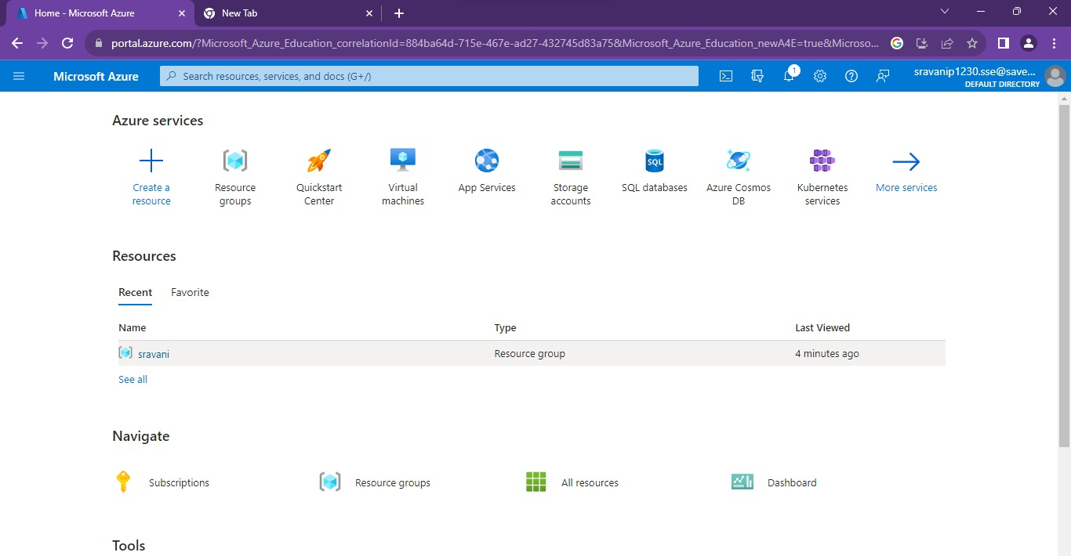

**Step 2:**

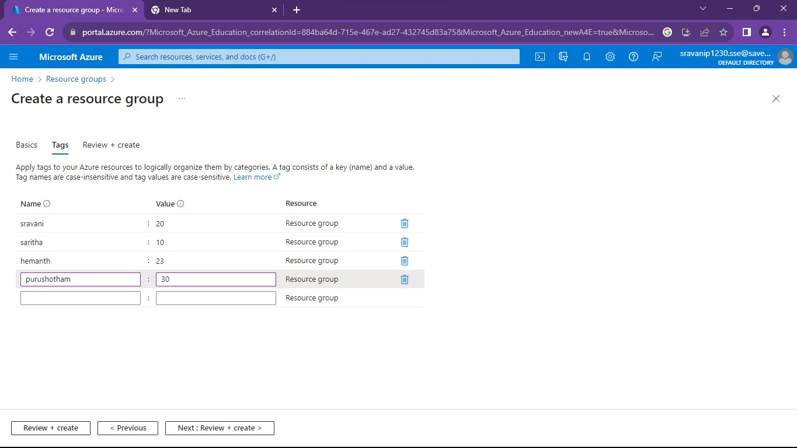

**Step 3:**

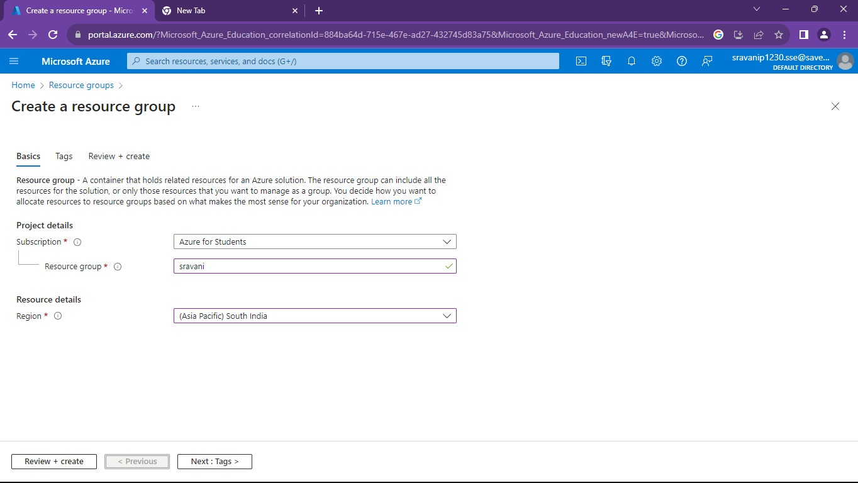

**Step 4:**

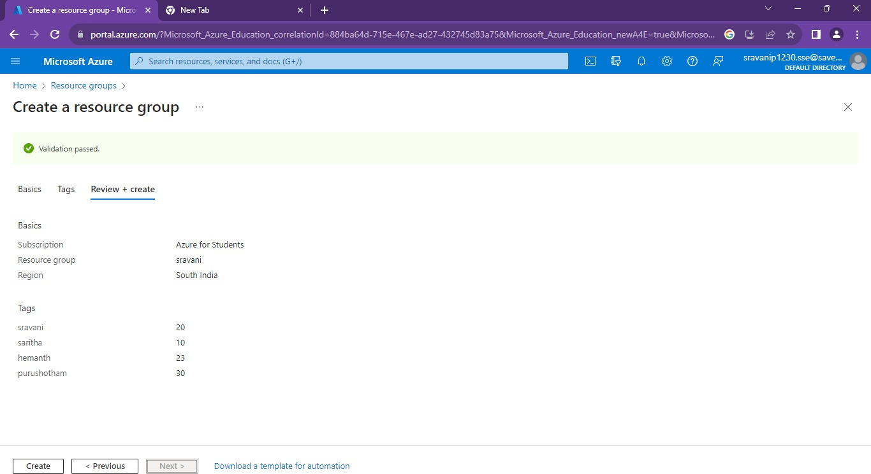

**Result:**

**By using the VMware workstation we have created and configured VM images with a host Operating system successfully.**